**Challenge 4: Enable Triaging and Clinical Support Systems**

**Objective:** To provide an efficient and seamless telehealth session with appropriate providers or hubs by intelligent routing through triage and clinical support

**Benefits:**

* Provides appropriate and on-time care cost-effectively
* Reduces overcrowding or unnecessary queues for telemedicine
* Reduces wait time and bottlenecks by processing patients more efficiently
* Provides rapid care to patients with low-risk health conditions.

**Features:**

* ***Implemented Features***
* Triage based on symptoms. This feature enables routing of a patient to the appropriate department
* Probable diagnosis based on the symptoms
* Algorithm gives a recommendation of investigations and treatment based on probable diagnosis.
* Added auto-suggestion of symptoms when user enters the name of symptom.
* Patient can see only probable diagnosis and department while the doctor/nurse view will be able to see diagnosis, department, investigations, and treatment.
* An experimental feature which supports entering of symptoms in multiple languages (currently Hindi, English) and gives the results in the preferred language of the patient/hospital staff. Other language feature(Hindi) supports only comma separated values(बुखार, चक्कर आना) and not the auto suggestion of symptoms.

* ***Suggested Features (Future scope of enhancement)***

Tele-triage additional features that can be implemented.

* Based on person requirement [telemedicine now and scheduled appointment]
* Based on age [pediatric, adult, geriatric]
* Based on language catering to local language [provider speaking local language and telemedicine UI in local language]
* Clinical decision support based on medications prescribed such as drug-drug interaction, duplicate drugs etc.
* Clinical decision support based on patient’s location such as air quality etc.
* Other languages can be

**Assumptions:**

* Due to limited data points, we have assumed that each symptom will equally qualify for a diagnosis but that is not the case. When we have more datapoints available (weighted average of each symptom towards a probable diagnosis), the algorithm can be further enhanced to improve the accuracy of the results provided by the algorithm. Also, we can change the method from cosine similarity to tf-idf weighted average with cosine similarities.
* Multiple language (English, Hindi) feature is experimental and needs the patient/hospital staff to enter the text in comma (,) separated format. E.g - बुखार, चक्कर आना. This is an experimental feature and can quickly be further developed to improve patient care and experience.

**Technical Design**

1. **Architecture Diagrams**

**This module will come under UHI and the EUA/HSPA will call this module as an API, and they will be able to get the desired result.**

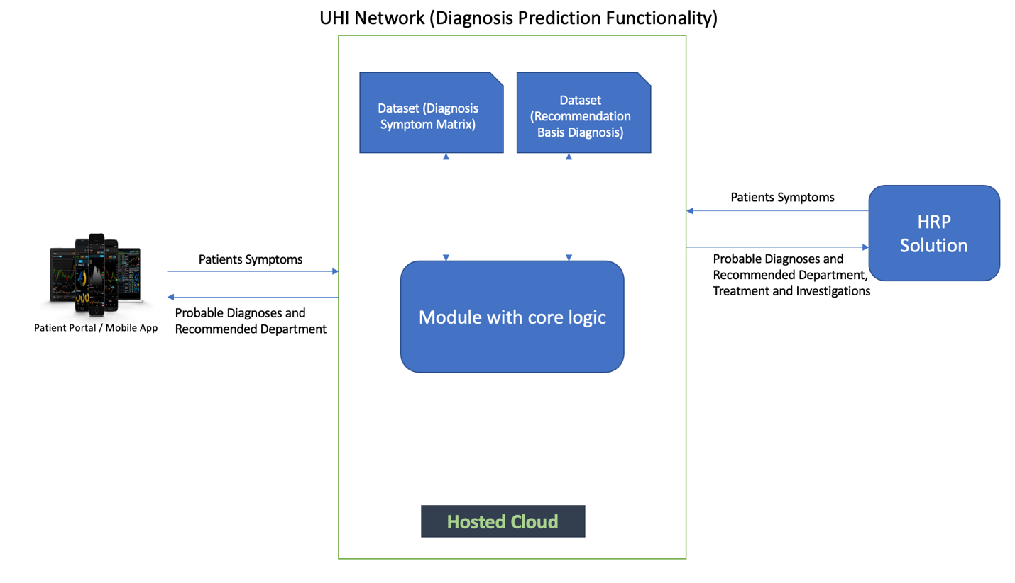

The components of current module are –

* **Frontend (UI) –** 
  + Symptoms are entered either by the patient/doctor/nurse. **Auto suggestion** **of symptoms** is also implemented to give ease of use during entry of symptoms.
  + There are 2 main workflows –
    - **Patient View –** Patient will enter the symptoms and will be able to see the **probable diagnoses and the recommended department** for those diagnoses.
    - **Hospital Staff View –** Hospital staff will be able to enter the symptoms for the patient and they will be able to see the **probable diagnoses as well as the recommended treatment, investigation(test) and the department** that the patient can be referred to.
* **Backend (API) –**
  + There are two main APIs –
    - **Diagnosis Prediction API –** This API predicts the probable diagnosis based on the symptoms entered by the patient. This API uses a methodology called Cosine Similarity to calculate the probable diagnosis, can be further enhanced with tf-idf weighted average if data points are available.
    - **Recommendation API –** This API recommends possible treatment, investigations, and department a patient could be referred to.
* **Datasets –** 
  + There are two datasets available –
    - Symptom Diagnosis 2 D Matrix
    - Department, Investigation and Treatment Recommendations

**Both these datasets have been uploaded on GitHub Repository.**

1. **Model APIs and Sample Data**

We have deployed our API’s on Heroku platform. The URLs to our API’s are –

* **Auto suggestion API: -**

URL – <https://intelli-search-csh.herokuapp.com/autopredict>

This API gives patient/hospital staff auto suggestion when they are entering the symptoms and helps them quickly select their symptoms and hence promotes ease of use.

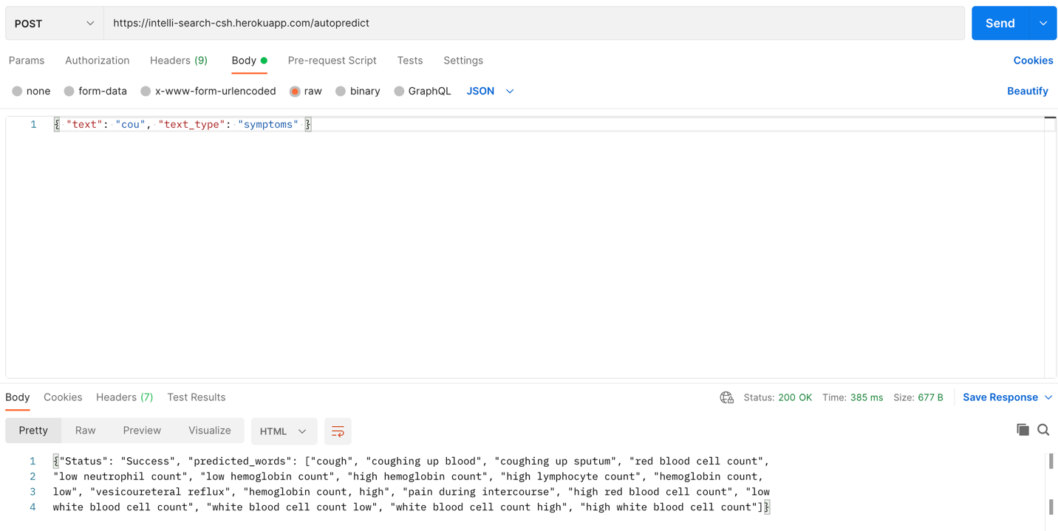

* **Diagnosis Prediction API: -**

URL - <https://diagnosis-prediction-model.herokuapp.com/diagnoisPrediction>

This API gives patient/hospital staff the probable diagnosis based on the symptoms entered with the probability of that diagnosis. This helps the hospital staff/ patient to see all the probable diagnosis and find recommendations for each diagnosis.

This API used the methodology of cosine similarity to calculate the probability for each diagnosis against the symptoms entered.

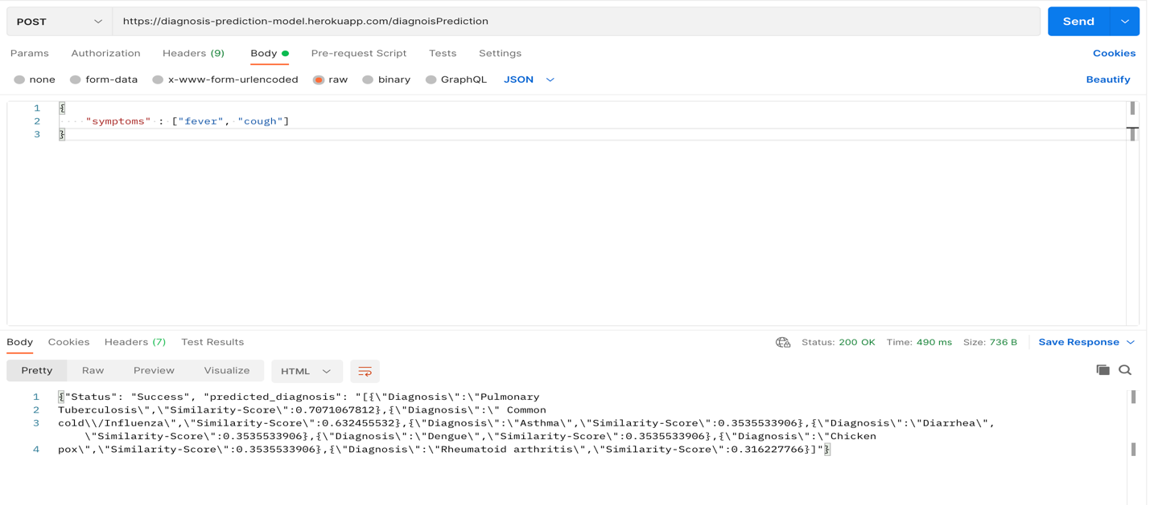

* **Recommendation Basis Diagnosis API: -**

URL - <https://diagnosis-prediction-model.herokuapp.com/recommendationBasisDiagnosis>

This API gives the patient / hospital staff recommendations on the possible treatment, investigation as well the department(speciality) the patient should be referred to.

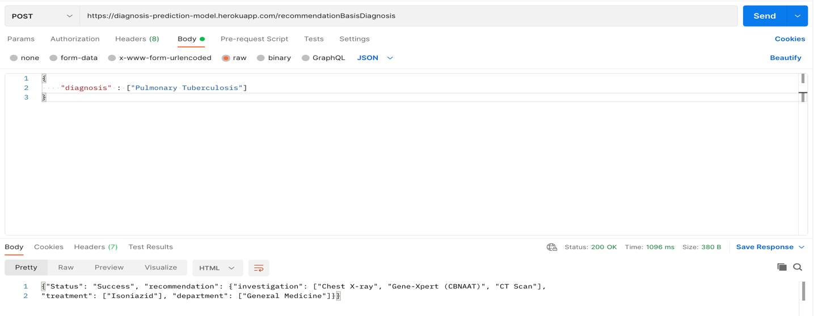

* **Language Translation API: (locally hosted)-**

URL - <http://localhost:3001/translate>

This API allows the patient / hospital staff to enter the symptoms as well as view the diagnosis, speciality, investigation and treatment in their preferred language(currently supported – English and Hindi).

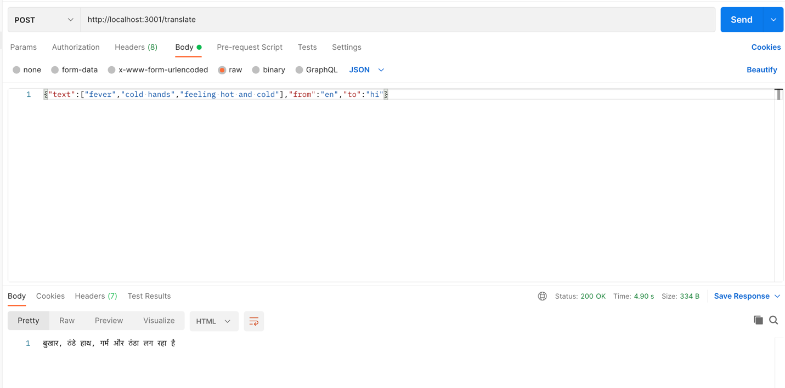

**How to set-up**

We have attached the readme file for both the backend and frontend defining the steps to deploy the application.

**We have added the sample dataset in GitHub Repo *(File Name - Symptom-Diseases-dataset.xlsx).* Since we had very less sample dataset, our recommendation is to use the symptoms that are given in sample set for a more accurate result.**

**Workflow with UI**

There are three workflows –

1. Nurse
   1. Select role as nurse.
   2. Enter patient details.
   3. Enter symptoms and search for probable diagnoses.
   4. List of all the probable diagnoses shown, click on any of them
   5. When nurse clicks on a probable diagnosis, she/he will be able to see the

recommended specialty, investigation, and treatment. The nurse can click on next probable diagnosis to see the recommendations for that diagnosis.

1. Doctor
   1. Select role as doctor.
   2. Enter symptoms and search for probable diagnoses.
   3. List of all the probable diagnoses shown, click on any of them.
   4. When doctor clicks on a probable diagnosis, he/she will be able to see the

recommended investigation, and treatment. The doctor can click on next probable diagnosis to see the recommendations for that diagnosis.

1. Patient
   1. Select role as patient.
   2. Enter patient details.
   3. Enter symptoms and search for probable diagnoses.
   4. List of all the probable diagnoses shown, click on any of them.
   5. When patient clicks on a probable diagnosis, he/she will be able to see the

recommended specialty. The patient can click on next probable diagnosis to see the recommendations for that diagnosis.

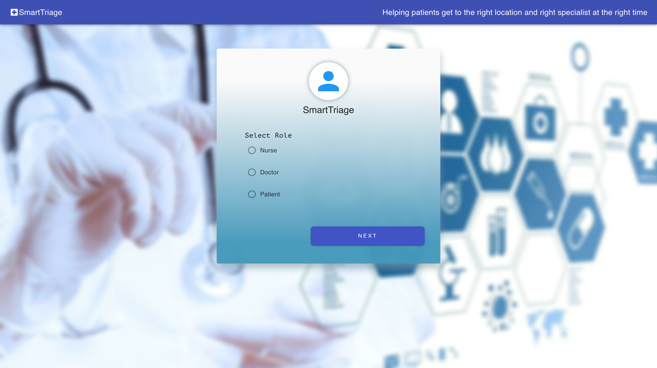

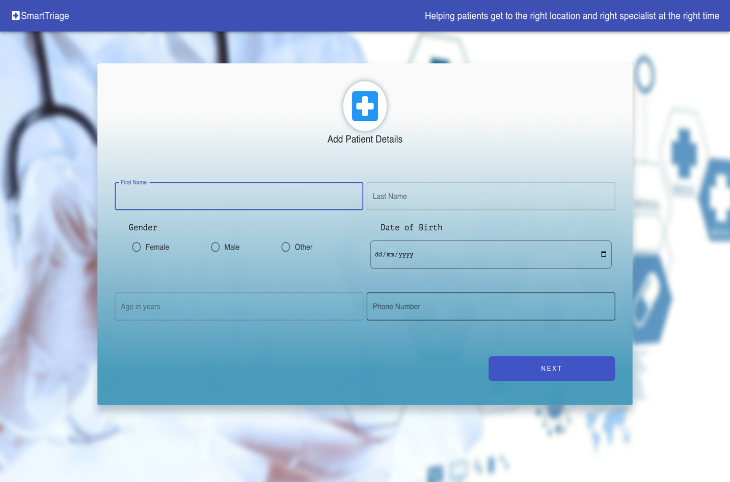

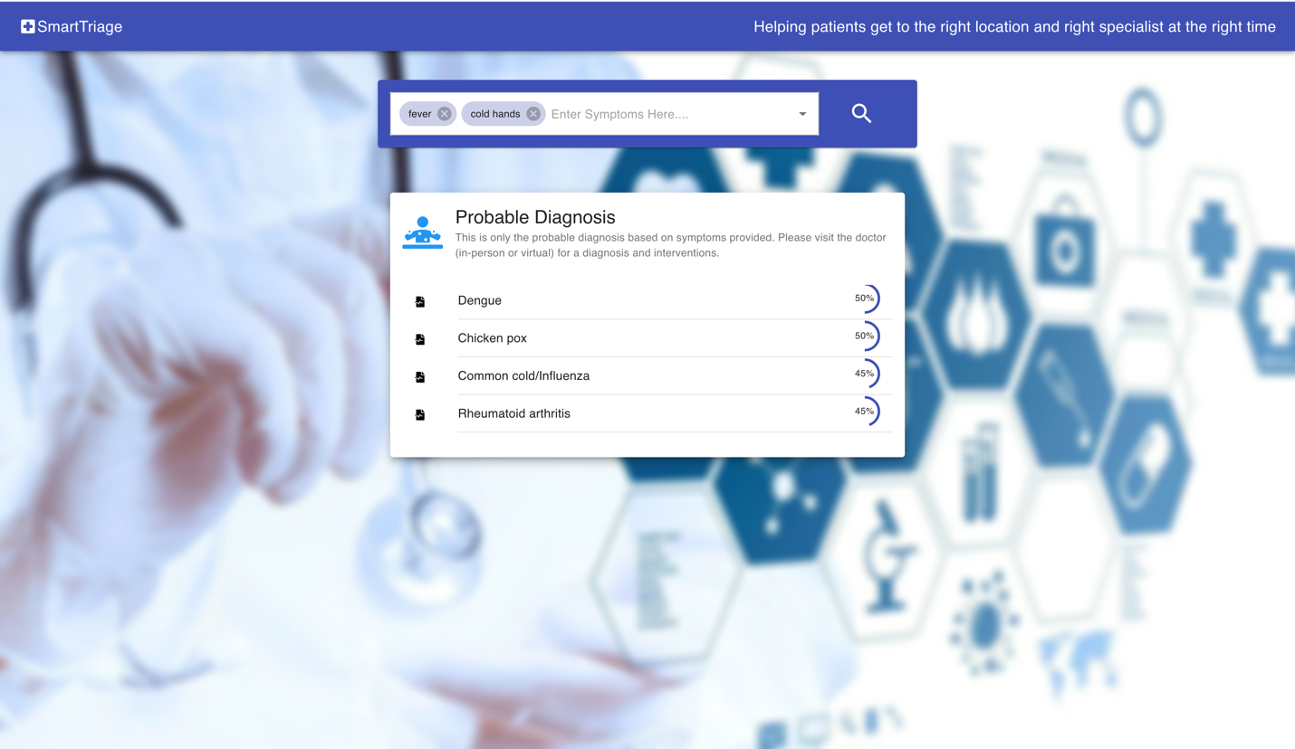

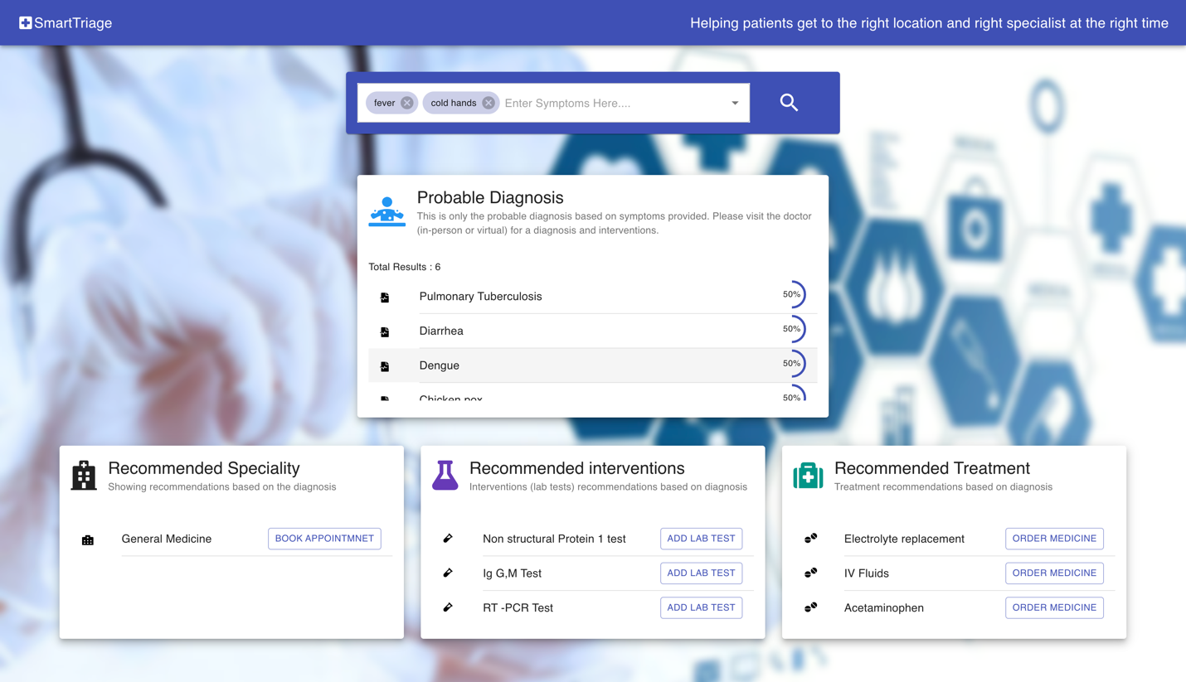

**Workflow with Video**

[**https://drive.google.com/file/d/1V_GMrtoTVT7tEs0n4Hfrd4Q43r949F1y/view**](https://drive.google.com/file/d/1V_GMrtoTVT7tEs0n4Hfrd4Q43r949F1y/view)

**Multiple Language Support Video (currently English and Hindi): -**

<https://drive.google.com/file/d/1lg5YB4lXVMOIcPLaOWgCPiOOtKt8toMD/view?usp=sharing>

